IT SYSTEM LOG ANALYZER
SUBMITTED IN PARTIAL FULFILLMENT FOR THE REQUIREMENT OF THE AWARD OF DEGREE OF
BACHELOR OF TECHNOLOGY
IN
COMPUTER SCIENCE


Submitted by
MAYANK KUMAR(2300290123006)
MRIDUL SHARMA(2300290129007)
VIKAS YADAV (2300290129016)

Supervised by
Dr.Sunil Kumar
Session 2025-26
DEPARTMENT OF COMPUTER SCIENCE
KIET GROUP OF INSTITUTIONS, GHAZIABAD
(Affiliated to Dr. A. P. J. Abdul Kalam Technical University, Lucknow, U.P., India)
May 2026

DECLARATION
We hereby declare that the submission of our project report entitled “IT SYSTEM LOG ANALYZER” is our original work and has been carried out under the supervision of Dr. Sunil Kumar, Department of Computer Science, KIET Group of Institutions, Ghaziabad. To the best of our knowledge and belief, this report contains no material previously published or written by another person, nor material which has been accepted for the award of any other degree or diploma of this university or any other institute of higher learning, except where proper acknowledgment has been made in the text.

Signature:-
Name:-Mayank kumar
Roll No:2300290129006

Signature:-
Name: Mridul sharma
Roll no:-2300290129007

Signature:-
Name:- Vikas Yadav
Roll no:-2300290129016

CERTIFICATE

This is to certify that Project Report entitled “IT SYSTEM LOG ANALYZER” which is submitted by MAYANK KUMAR , MRIDUL SHARMA , VIKAS YADAV in partial fulfillment of the requirement for the award of degree B. Tech. in Department of Computer Science of Dr. A.P.J. Abdul Kalam Technical University, Lucknow is a record of the candidates own work carried out by them under my supervision. The matter embodied in this report is original and has not been submitted for the award of any other degree.

Date:- Supervisor
Dr. Sunil Kumar
(Associate Professor)
Date:- Dr. Ajay Kumar Shrivastava

(Dean CS)

ACKNOWLEDGEMENT

We take so much pleasure in reporting an experience of B. Tech Project taken in B. Tech. Final Year. To professor Dr. Sunil Kumar, Department of Computer Science, KIET, Ghaziabad, we are especially indebted with gratitude, because his/her support and help were always present and made us keep on our course much easy and secure. We have always been inspired by his/her sincerity, thoroughness and perseverance. It is his conscious work that our work has only seen the light of day.
We also take the opportunity to acknowledge the contribution of Dr. Ajay Kr Shrivastava, Dean (Department of Computer Science), KIET, Ghaziabad, for his full support and assistance during the development of the project.We also do not like to miss the opportunity to acknowledge the contribution of all the faculty members of the department for their kind assistance and cooperation during the development of our project.
We also do not like to miss the opportunity to acknowledge the contribution of all faculty members, especially faculty/industry person/any person, of the department for their kind assistance and cooperation during the development of our project. Last but not the least, we acknowledge our friends for their contribution in the completion of the project.
Date:
Signature:
Name : Mayank Kumar
Roll No :2300290129006

Date:
Signature:
Name : Mridul Sharma
Roll No : 2300290129007

Date:
Signature:
Name : Vikas Yadav
Roll No : 2300290129016

ABSTRACT
Modern IT infrastructures generate a large volume of system logs from servers, applications, and network devices. These logs contain valuable information about system activities, performance, warnings, errors, and security events. Analysis of these logs however is complex and time-consuming manually because of the sheer volume of information and the unstructured format logs are written in. This poses a solution to an automated system that can be useful in processing and analyzing system log data.
The proposed project is aimed at the creation of an IT System Log Analyzer which will automatically collect, analyze and process log files that have been produced by various IT systems. The system is developed in Python and incorporated with a graphical user interface coded in Tkinter. It reads the logs, extracts useful information such as the time of the log, the log level and the data according to regular expressions and formats the data in a more readable format. There are levels of severity of the log entries such as INFO, WARNING and ERROR so that an administrator can be able to trace problems within the system very easily.
The characteristics such as the ability to filter logs, as well as export the results in CSV format and further analysis and reporting of results, are also effective in making it easier to use. The systematized presentation of the logs can help administrators to find out abnormalities quicker, system failures, and system performance more effectively.
The major aim of the project is to reduce the number of individuals who will be required to carry out manual works when analysing logs and provide a convenient utility to trace the system at their disposal. IT System Log Analyzer will enhance the stability of the system, its working efficiency and help the organization to detect the possible issues and threats in security more efficiently since all the processes of processing and visualizing log will be automated.
Additionally, the proposed system will become a scalable platform that can be subsequently expanded in the future with technical capabilities such as real-time tracking of the logs, strange behavior detection using machine learning and links to the monitoring systems on the cloud. These improvements would enable the system to accommodate the current IT environment, where it is important to keep track of the system and to react promptly to system activities.
Overall, the project demonstrates that the automated tools of log analysis can support IT specialists in dealing with the dynamic environment of the system, and the stability, performance, and security of the modern computing infrastructures.

TABLE OF CONTENTS | Page No.
DECLARATION……………………………………………………………………. | ii
CERTIFICATE……………………………………………………………………… | iii
ACKNOWLEDGEMENTS…………………………………………………………. | iv
ABSTRACT………………………………………………………………………..... | v
LIST OF FIGURES…………………………………………………………………. | ix
LIST OF TABLES…………………………………………………………………… | x
LIST OF ABBREVIATION…………………………………………………………. | xi
CHAPTER 1 (INTRODUCTION)…………………………………………………. | 1-5
Introduction to Project……………………………………………….......................... | 1
1.2.Project Category…………………………………..…..……………………….…  1.3.Objectives……………………………………………….………………….…….  1.4.Structure of Report………………………………………..……………………… | 2  3  5
CHAPTER 2 (LITERATURE REVIEW)…………………………………………. | 6-9
2.1.Literaturereview……………................................................................................ | 6
2.2. Research Gaps .…................................................................................................  2.3. Problem Formulation.…...................................................................................... | 8 8  9 9
CHAPTER 3 (PROPOSED SYSTEM) …................................................................. | 11-12
3.1. Proposed System ……..........................................................................................  3.2.Unique Features of The System…………………………………………………. | 11  12
CHAPTER 4 (REQUIREMENT ANALYSIS AND SYSTEM SPECIFICATION)... | 14-18
4.1 Feasibility Study……………………………….……………………………….... | 131 14
4.2 Software Requirement Specification…………………………………………….. | 1 14
4.2.1. Data Requirement………………………………………………………….….. | 15
4.2.2. Functional Requirement………………………………………………………..  4.2.3.Performance Requirement……………………………………………………...  4.2.4. Maintainability Requirement…………………………………………………..  4.2.5.Security Requirement…………………………………………………………..  4.3.SDLC Model Used……………………………………………………………….  4.4System Design…………………………………………………………………….  4.4.1.Data Flow Diagrams……………………………………………………………  4.4.2. Use Case Diagrams…………………………………………………………….  4.5 Databse Design…………………………………………………………………... | 15  15  16  16  16  17  17  18  18
CHAPTER 5 (IMPLEMENTATION)………………………….................................. | 1 1 19-24
5.1.Introduction Tools and Technologies Used............................................................ | 19
5.2.System Architecture................................................................................................  5.3.Module Description……………………………………………………………...  5.4 Tools and Technologies Used…………………………………………………….  5.5 Database Design………………………………………………………………….  5.6 User Interface Design…………………………………………………………….  5.7 Implementation Challenges………………………………………………………  5.8 Summary………………………………………………………………………….  CHAPTER6 (TESTING AND MAINTENANCE)…………………………………..  6.1.Testing Techniques and Test Cases Used………………………………………...  6.2 Testing Objectives………………………………………………………………..  6.3 Types of Testing Performed……………………………………………………...  6.4 Test Cases and Results…………………………………………………................  6.5 System Performance……………………………………...……………… 28  6.6 Maintenance and Future Enhancement……………………...…………… 28  6.7 Summary…………………………………………………….…………… 29  CHAPTER 7(RESULTS AND DISCUSSIONS)……………………………. 30-33  7.1. Presentation of Results……………………………………………………. 30  7.2. Performance Evaluation……………………………..……………………. 31  7.3. Key Findings……………………………………………………………… 33  CHAPTER 8 (CONCLUSION AND FUTURE SCOPE)……………………. 35-37  8.1.Conclusion……………………………………………………………….. 35  8.2.FutureScope…………………………………………………………...…. 36 | 20  20  22  22  23  23  24  25-29  25  25  26  27
REFERENCES……………………………………………………………….. 37
ROJECT REPORT PLAGIARISM REPORT……………………………….. 38-39

LIST OF FIGURES

Figure No. Description PageNo.

Figure 4.4.1 Data Flow Diagrams 17
Figure 4.4.2  Figure 7.1 | Use Case Diagrams  System Performance Accuracy Curve | 18  31

LIST OF TABLES

Table. No. | Description | PageNo.
4.5  6.1 | Database Design  Test Case Validation Results of IT System Log Analyzer | 18  27
7.1 Performance Evaluation of IT System Log Analyzer 33

LIST OF ABBREVIATIONS
Abbreviation Full Form
IT | Information Technology
GUI | Graphical User Interface
CSV | Comma-Separated Values
CPU | Central Processing Unit
RAM | Random Access Memory
OS | Operating System
API | Application Programming Interface
ML | Machine Learning
AI | Artificial Intelligence
SIEM | Security Information and Event Management
IDS | Intrusion Detection System
JSON | JavaScript Object Notation
PY | Python Programming Language

CHAPTER 1
INTRODUCTION

  - Introduction to Project
System logs are an important component of modernity in IT infrastructures to monitor activities of the system, identify the error and ensure the security of network and application. System logs are records automatically created and which record significant events that take place within the servers, applications, operating systems and network devices. The logs can include useful information, like user activities, warnings, system errors, timestamps and performance metrics. These logs help administrators know how the systems operate, diagnose and maintain the smooth operation of the systems.
Nonetheless, the volume of log data generated by the digital infrastructure and cloud-based systems has also increased significantly as organizations become increasingly reliant on these types of systems. The huge business might generate thousands or even millions of log entries per day. The task of analyzing such large volumes of log files becomes extremely challenging, time-consuming and inefficient in case of manual analysis. System administrators are required to read long log files to find out the errors, warnings or audits that can be security threats, a fact that elevates the risk of overlooking vital events that may impact the performance or security of the system.
Moreover, the log data tends to be discovered in the form of unstructured or semi-structured data, thus complicating the interpretation process. Other systems and applications may produce logs that are formatted in dissimilar ways and therefore, analysis of such logs can be more difficult. The observations in the logs could contain important patterns or anomalies that might go undetected because of the complexity and volume of the data. This is where automated system comes in- to process and analyze log data efficiently.
The usage of automated logic analysis of logs is gaining popularity with the rapid development of technologies used in data analytics, artificial intelligence, and machine learning. With these systems, it is possible to manipulate large amounts of log data, identify trends, locate anomalies and make useful insights to the system administrators. Automated log analysts save manual work needed to patrol logs and enhance accuracy and efficiency of monitoring systems.
The proposed project will create an IT System Log Analyzer; it will be a computer program that will be used to read, aspect, and understand system log files automatically. The system reads log files created by IT systems, isolates valuable data like timestamp, log level and message and places the data in a form of a table that facilitates easy analysis. Through the classifications of the log entries to severity levels like INFO, WARNING and ERROR, the system enables administrators to quickly find out the critical issues within the system.
The system will be designed with features like uploading of log files, automatic log parsing, selecting and filtering of the analyzed log entries based on their severity levels, and also exporting of the analyzed log data in the form of CSV and use it to encourage reporting. It will also create a graphical user interface to enable the system to be user-friendly and accessible even by non-technical users.
This project is aimed at helping system administrators but not eliminating them as it will offer them a tool that will make the log analysis easier and decision-making will be enhanced. The proposed system supports human efforts reduction, error reduction, and overall reliability and safety of IT systems by automating the log monitoring and analysis process and decreasing human error.

1.2 Project Category
Information about the IT System Log Analyzer project belongs to the sphere of Software Engineering, Data Analysis, and Cybersecurity which are significant in contemporary computer science. The process of these fields is to come up with intelligent systems capable of efficiently converting large chunks of system data into valuable insights to aid in system monitoring and decision-making.
The conventional system monitoring techniques are very cumbersome, based largely on human inspection of logs by system administrators. However, with an increasingly complex IT infrastructure, and with the new systems that produce more log data, manual monitoring is no longer a proven methodology. It is necessary to possess roboticized tools that cannot be avoided to analyze log-ins of the system and understand the possible troubles before they impact on the system functionality or integrity.
The project mainly concerns log data analysis; a log processing and mentation or even collection of the log data produced by IT systems.The tools of the log analysis can help the administrators to identify system failure, performance as well as security threat through identification of patterns and anomalies within the logs. They have applications in network monitoring, cybersecurity and system administration.
Algorithms of such programs and the data processing algorithms which are used in the system design in the current project derive useful information out of the raw log files. The system is constructed with technologies like Python is superior in terms of file processing and data dispensation and data visualisation libraries and it could be a suitable language in the development of log analysis software.
The another inter-connection or overlap that the project has with the body of research regarding cybersecurity is the fact that the monitoring system logs is an important practice of detection of doubtful activity, unauthorized access efforts, and the threat of a cyber attack. It may become a significant sign of the safety threat since organizations will be able to use automatic system logs analysis and, in such a way, soon detect an abnormal pattern or errors.
So, this project is a convergence point between Software Development and Data Analysis and Cybersecurity and illustrates how smart software systems may be engineered in such a way that they can be utilized to enhance the monitoring of the systems, make them more efficient, and serve to support environmentally-safe IT systems.
1.3 Objectives
The most important goal of the project is to design and create a useful system which can automatically analyze with scheme log files and can provide useful results to system administrators. The objectives of the project will be the following:

To develop an automated log analyzing system:
The project will aim at providing an automatic system in reading and processing system log files then dropping the manual examination of the logs.

To add a systematized system of log parsing:
To derive out a system of automated log analysis:sage of regular expressions and file processing methods the raw log files are to be analyzed to identify timestamps, level of logs and log messages with u which will in turn help the system extract important information.

In order to sort the log entries according to degrees of severity:
The logs will be secret into various levels like the INFo, warning and error so that the administrators can easily identify important events and error in use of the system.
In order to offer filters to analyze logs:
Log entries will be filterable by severity level and users can quickly cut down on only the critical errors or warnings.
To send analysed log data to be reported:
The system will enable users to export filtered log information in CSV format that can be exported to report, audit or further analyze.
In order to create a graphical interface that is user friendly:
To make it easy to use, a graphical user interface will be created where customers will be able to upload the log files, see the analyzed data and navigate the system.
To enhance the performance of system monitoring:
The project will help minimize the time and efforts spent on the analysis of system logs and enhance accuracy of problem detection.
To establish a basis on improvements in the future:
The created system can be upgraded in the future with new features like real-time monitoring of logs, anomaly detection with machine learning can be applied, as well as connecting with systems in the clouds.
On the whole, the project is supposed to produce a stable and workable solution that assist administrators in tracking the actions of systems, addressing problems in their initial phases, and ensuring the stability and safety of infrastructures in IT.
1.4 Structure of Report
The project report is addressed systematically and in an orderly way in an attempt to make the work understandable and logical. The first chapter of the report is a chapter of introduction where the background information of analysis of system logs, problem statement, objectives of the project and scope of the study is presented.
The second chapter brings the literature review in which past studies and current tools that are available about the analysis of logs and system monitoring are discussed. This chapter assists to define the basis of the project as strengths of existing approaches and limitations are analyzed.
The report will follow the process of the literature review by elucidating the proposed system and methodology that details how log files are gathered by the system, the log data processed within the system, and the log entries analyzed in the system. The workflow of the system and algorithms that we filter and indicate the log parsing is also presented in this chapter.
The other chapter is devoted to technologies and tools utilized in the system development, the role of programming languages, frameworks and libraries utilized during the implementation are explained.
The chapter on system design provides diagrams like flowcharts and architecture diagrams among other design models depicting how the IT System Log Analyzer works.
The implementation and results chapter talks about how the system has been implemented, the way log files can be processed and how the results will be presented to the user. It also assesses the performance of the system on the basis of how it measures the efficiency of analyzing the log data.
Lastly, at the end of the report is the conclusion and the scope of the future, where the report summarizes the findings of the entire project and offers some potential improvements or enhancements that can be made in the next versions of the system.
CHAPTER 2
LITERATURE REVIEW
2.1 Literature Review
Over the past few years, the velocity of the growth of digital infrastructure and cloud-based systems has increased dramatically the volume of log data produced by IT systems. System logs capture the occurrences of system errors, warnings, user activities and security alerts. These logs are very useful in understanding the reliability, security and performance of computer systems. Nevertheless, the traditional log analysis process has become very cumbersome and tedious because of the large and complicated amounts of log data. Consequently, automated log analysis systems have become highly popular with system administration, cybersecurity, as well as data analytics.
The initial studies in the field of log analysis have helped to detect failures in the system and identify system problems during runtime analysis through log methodologies using console logs. Xu et al. suggested an approach of identifying large scale system issues through console log mining of distributed systems. Their study showed that the patterns could be useful in identifying the abnormal behavior of the systems and also in detecting problems in the running systems in a complex computing system by studying patterns in system logs [1]. This article emphasized the need of automated systems in processing massive amounts of logs.
Subsequent studies focused on application of statistical and machine learning to detect anomalies in system logs. He et al. carried out a thorough system study of log analysis as a tool to detect anomaly and underlined that more conventional and simple rule-based methods are not adequate towards managing the increasing amount of log information emitted by contemporary IT infrastructures [2]. Their research recommended that automated log analysis system could be used to enhance monitoring of the system and assist administrators identify anomalies more effectively.
The other significant study by Yuan et al. did a research on production failures in distributed systems of data intensive systems and discovered that failure of many systems could be avoided by efficient testing procedures and log monitoring [3]. Their study proved that logs are important since they give vital information on how to diagnose failure in the system and the underlying cause of operations.
Lou et al. proposed systems to mine invariants in console logs to understand system malfunctions in large-scale distributed systems [4]. Their approach was to find patterns and relationships of the log events to detect an abnormal behavior of the system. Whilst this was useful in controlled settings, it had a weakness in not being able to deal with noisy or dynamic log formats as would be encountered in real world systems.
Recent developments in machine learning and data analytics have added additional functionality to data analysis systems. Fu et al. suggested a method of able to define execution anomalies in a distributed system based on the analysis of unstructured logs [5]. Their research found that machine learning methods are able to detect latent patterns and anomalies of large data sets of logs, enhancing the reliability of the system and fault detection.
Studies by Zhang et al. were aimed at creating powerful log-based anomaly detection methods that are able to process volatile or dynamic log data [6]. One issue that their work tackled is that the different systems and applications used logs in varying formats, making it a significant issue in log-based analysis.
Splunk and open-source software including ELK Stack ( Elasticsearch, Logstash, and Kibana ) are also commercial tools that have helped to develop modern log management systems. These systems offer very strong log collection, indexing, searching and visualization facilities that allow businesses to analyze the real-time activities within the system and identify threats that may be present [7].
Although these improvements are in place, the majority of the current log analysis products need a complex system, a substantial system of computers, or higher licensing fees. Hence, it is necessary to develop easy and lightweight log analysis tools that are capable of analyzing logs efficiently and offer useful information to the system administrators.
The present project is based on the results of earlier studies to create an IT System Log Analyzer, which is capable of reading, parsing, and analyzing logs of the system automatically. The offered system is aimed at offering a rather straightforward, but efficient way of analysing log files, finding errors, and increasing the efficiency with which the system monitoring may be conducted.
2.2 Research Gaps
Despite the notable advancements made in the sphere of automated analysis of logs, there are still a number of limitations and gaps in research. The biggest gaps include the unavailability of simple and lightweight tools to analyze log, easily accessible to small organizations or single system administrator. The larger log management systems provided such as enterprise Security Information and Event Management (SIEM) systems require complex architecture, complex set-ups and expensive operations.
Diversity and inconsistency of log formats is another problem. Depending on the application, operating system and network device the logs generated by them come in various formats and therefore it is difficult to come up with a universal solution of log analysis. Many of the existing systems are likely to operate with a particular kind of logs, and may not be effective with alternative logs.
Scalability of data is another issue of research into log analysis. In distributed systems and cloud computing, new IT environments generate vast amounts of log data that are very large. Such large amounts of data require a rapid way of handling data, and effective algorithms that can ensure the outcome of the analysis is provided within the required time.
The other research gap is linked to the detection of anomalies and security threats of log data. Though there are many systems founded on approaches of collecting logs and visualizing them, fewer have effective mechanisms to determine abnormal patterns or any other possible security threats automatically.
Additionally, most of the available log analysis software focuses on advanced analytics, and has minimal consideration of usability and accessibility. Just to detect serious system issues, and not to use complex configurations and advanced skills, system managers should have simple tools to allow them to easily upload log files, filter events, and determine related system issues.
Based on these gaps, we need a system which is easy to use and has efficient way of analyzing the log files, in order to aid in the analysis of the log files and obtain the relevant data and also assist the administrator to monitor the operations of the entire system.
The suggested IT System Log Analyzer will help overcome those difficulties by introducing a convenient and convenient log analyzer solution that provides automated log analysis.
2.3 Problem Formulation
Restructuring IT systems result in numerous log data volumes that document system processes, faults, alerts, and security issues. The logs are essential in the maintenance, troubleshooting and detection of security threats. However, log files are difficult to analyse manually in a complex manner.
System administrators usually must sift through thousands of log entries in order to find specific errors or suspicious behavior. When the logs are large, crucial activities are ignored and this would delay the process of noting that a system failure or sign of a security attack has occurred. Also, logs produced by other systems might be in various formats and hence, they may not be very easy to analyze them together.
The problem that this project should solve is that it should develop an automated system which can effectively analyse system log files. The system must be capable of reading log files, pruning the information to be useful like timestamps, log levels, and messages and sorting this information into an organized format that can be readily interpreted.
Technically, the issue may be designed as a task of parsing and categorizing logs. Given a collection of log records made by a system, we have the goal of processing the raw log entries and categorizing the entries into various classes according to their nature: INFO, WARNING and ERROR. They should also have the ability to filter the log entries depending on the severity level and provide an option of exporting the data analyzed to be used in further investigation.
Another significant issue is how to ensure that the system can handle changes in log format as well as process high volume of log data without impacting performance. The solution should be able to give correct parsing, effective process of data processing as well as a user friendly interface that would enable the administrators to operate the system without a lot of difficulty.
In a nutshell, this project deals with the following problem, which is, development of a stable IT System Log Analyzer capable of automatically processing and analysing system logs to enable an administrator to observe system problem and ensure stability and security of IT infrastructures.

CHAPTER 3
PROPOSED SYSTEM

3.1 Proposed System

The system will be an IT System Log Analyzer that operates automatically to read, process and analyze the system log files created by servers, applications and operating systems. System logs are rich in information that relates to system, errors, warnings and security events. Nevertheless, because of the high amount of log data produced in the contemporary IT setting, it is not feasible to use logs files manually, which wastes a lot of time.
The offered system offers an automated regime that makes the process of the log monitoring and analysis simplified. In the system, log files can be uploaded via the mode of the graphical user interface. After the log file is uploaded, the system reads the log entries and then extracts important information based on regular expression techniques like timestamps, log levels, and messages.
Once the corresponding data has been extracted, the system then puts the entries of the log into a tabular format and shows it in a graphical interface. The log entries are designed into various levels of severity like INFO, WARNING and ERROR and this allows the users to easily spot significant system events and possible problems.
There is also the filtering capability of the system, whereby the user is given an option to see the particular entries in the logs depending on the level of severity. To illustrate, administrators can easily see error messages only, and this can help them quickly locate the failures of the system. The feature will save time on the analysis of large log files.
Moreover, people can save the filtered log information to a CSV file to be reported and analyzed. The data which is exported may be audited in the system, or it may be monitored in the performance or it can be investigated in terms of security.
The proposed system is written in Python programming language with the assistance of libraries, like Tkinter, to develop graphical user interface, regular expressions to parser log contents and CSV modules to export data. Python allows developing in a flexible environment in the most efficient way to analyze data and process large text files.
In total, the proposed IT System Log Analyzer provides a user-friendly and efficient solution for analyzing system log data. The system also improves reliability and security of information systems through mechanization so that performance administrators can monitor the performance of the systems by parsing, classifying and visualizing logs automatically to detect errors at an early phase and better their sense of the error.

3.2 Unique Features of the System
The information technology System Log Analyzer is also useful, easy to use and effective in monitoring the systems which have a number of unique features.
1. Automated Log Parsing: It is able to read and process log files automatically without a human worker having to read the log files manually. It works with regular expression to read raw log information to extract the valuable fields, including the timestamp the log level and the message.
2. Presenting the Structured Logs in an easy to view formatThe assumption of the examination is presented in a tabular structure with a graphical user interface. It is easy to read and interpret log data with this.
3. Log Classification Giving to the severity The system classifies the log entries into three categories: INFO, WARNING and ERROR. This classification assists the administrators to classify, at a glance, the most significant issues of the system.
4. Filters to LogsBased on the severity level, end users are allowed to filter the log entries. As an instance, they may simply display error logs or warnings, thus letting individuals to not need to be attentive to the crucial occurrences of the systems.

5. Exporting to CSV Users feature allows you to export the analyzed log data in CSV format courtesy of the system. The feature assists with generating reports, following of records and additional analysis using other tools.
6. Interface The system is easy to use due to a graph-user interface (GUI) developed using Tkinter. The user is not required to study a lot about computers, as he/she can post log files, look at the data that is being parsed, and filter without far knowledge.
7. Lightweight and work well The proposed system is light, compared to other large systems of handling logs, that require a lot of infrastructure to operate, and perhaps only perform well on special drive computers.
8. Scalable Design—Better in the Future The system is modular, and thus it can be extended to provide additional functions such as monitoring logs in real-time, machine knowledge based anomaly discovery, and cloud integration.
These characteristic characteristics give the IT System Log Analyzer an easy tool to make log analysis more nearby and enhance system monitoring.

CHAPTER 4
REQUIREMENT ANALYSIS AND SYSTEM SPECIFICATION

4.1 Feasibility Study
A feasibility study will be carried out to establish whether the proposed system is a viable and useful one to be implemented. It considers the following factors: technical feasibility, economic feasibility and operational feasibility. Technical Feasibility
The IT System Log Analyzer is technically feasible, because the application is written in ubiquitously available programming language Python, Tkinter and regular expressions.
These technologies offer effective file processing, data analysis as well as graphical interfaces development tools. The system does not involve intricate hardware or special infrastructure and can operate in regular computer systems.
Economic FeasibilityThe system itself is economically viable as it takes advantage of open-source technologies and tools. Python and its libraries are free and this makes development and deployment less expensive. It is very affordable to organizations because it does not entail the use of expensive software licenses and specialized equipments.
Operational FeasibilityThe system is user friendly and no much technical knowledge is needed. The administrators can just post the log files and examine them using the graphical interface. This enhances monitoring of the system and less manual labor is required which makes the system viable.

4.2 Software Requirement Specification
Software Requirement specification (SRS) explains the functional and non-functional needs of the proposed system. It explains system behavior, anticipated features and system performance requirements.
The IT System Log Analyzer is meant to read system log files, analyze these files and convey helpful information in a proper format.

4.2.1 Data Requirement
System log files are the input data in the system. Such log files can include data such as:
- Timestamp of events
- Level of log (INFO, WARNING, ERROR)
- Log messages indicating system activities.
- System event details
Log data is sorted out and arranged into a tabular format to enable easy analysis. The system also has stored the filtered log data in a temporary storage which can be exported to CSV files.

4.2.2 Functional Requirement
Functional requirements explain what operations the system should do.
- The system ought to be capable of the following:
- The system must enable users to post system log files.
- The system ought to read and process the entries in the log file that is uploaded.
- The system must be keen to extract vital facts like the timestamp, level of logs, as well as the message.
- The system must be able to show the log data in a well-organized table.
- The system needs to categorize the log entries according to the level of warning e.g. INFO, warning, error etc.
- The system must enable people to filter log entries on the basis of severity.
- Other functionalities to be included in the system: The system must take the filtered log data and enable the export in a CSV format.

4.2.3 Performance Requirement
The system is to work effectively when handling the log files.
Performance requirements include:
- The system must be able to operate on log files fast and in an efficient manner.
- The system must be able to cope with large log files with little or no delay.
- The interface should show the entries of the logged data after parsing of the log in real time.
- Log filtering and exporting should remain stable in operation of the system.

4.2.4 Maintainability Requirement
Maintainability is a term used to describe the simplicity with which the system can be changed or improved.
The offered system is worked out with the help of modular programmings, which simplifies the code and its maintenance. Subsequent modifications like introduction of new features or enhancement of log analysis processes can be realized without significant changes to the architecture.
Maintainability is also enhanced by proper documentation and organization of the code.

4.2.5 Security Requirement
Security is a critical need in systems that deal with system logs.
The system provides a platform with basic level of security, which includes:
- Allowing only valid log files to be processed.
- Detection and prevention of illegal alteration of log data.
- Making sure that exported log data is consistent with the original information.
Subsequent system modifications can be added to the system comprising more security like user identification and encrypted logs.

4.3 SDLC Model Used
-The Waterfall Model is the Software Development Life Cycle (SDLC) framework to be used in this project.
-Waterfall Model is a developmental procedure which is sequentially developed; one stage has to be finished before another one can start.
The stages of the Waterfall Model to be adopted in this project comprise:
- Requirement Analysis
- System Design
- Implementation
- Testing
- Deployment
- Maintenance
This model applies in the IT System Log Analyzer since the project requirements are outlined and the project development has a structured process.

4.4 System Design
System design communicates the general design and framework of the proposed system. It determines the interaction of various elements to the system.
IT System Log Analyzer has the following key components:
• Log File ReadingModule.
• Log Parsing Module
• Log Filtering Module
• Log Visualization Module
• Log Export Module
These modules are interdependent and utilized in processing and analysing log files.

4.4.1 Data Flow Diagram (DFD)
A Data Flow Diagram (DFD) is a representation of the flow of data in the system.
Level 0 DFD (Context Diagram)
User → Log File to the uploaded logs • IT System Log Analyzerstyle Log Analysis Display User.
Level 1 DFD
1. User uploads log file.
2. Reading and processing of log file by system.
3. The regular expressions are used to extract the logs.
4. Parsed data is stored as structured.
5. The logs are shown in tables.
6. Logs may be filtered and exported to CSV file.
Figure 4.4.1 (Data Flow Diagrams)
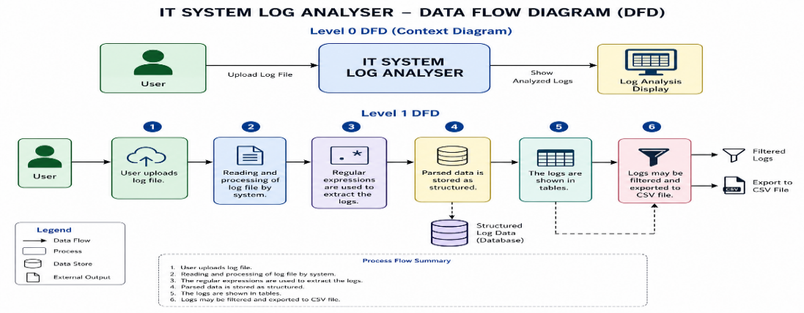

4.4.2 Use Case Diagrams
The user interaction with the system is depicted in the use case diagram.
Main Use Cases:
User can:
- Upload log files
- This will show me the data of the parsed logs.
- Filter by the level of severity in logs.
- Export log data
Actors:
- System Administrator / User
The user communicates with the system in order to analyze log files and to receive useful information.
Figure 4.4.2 Use Case Diagrams
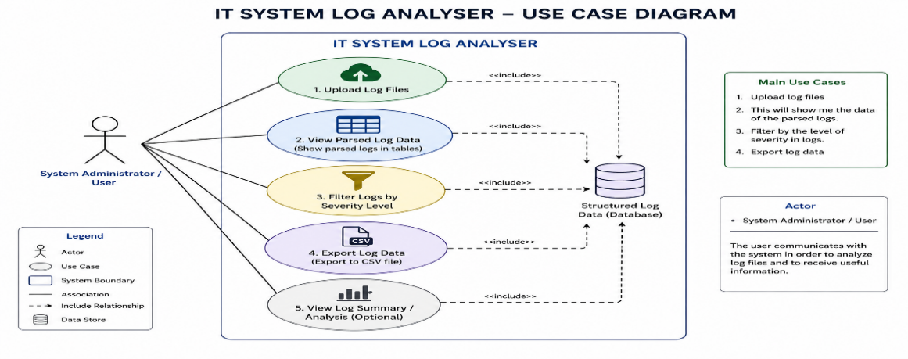

4.5 Database Design
The system proposed does not necessitate a sophisticated database since the processing of log files is done directly with the input files. The system does temporarily but convert entries into a structured form as the log is being processed.
A log record consists of the following properties:
Field | Description
Timestamp | Time when the event occurred
Log Level | Severity level (INFO, WARNING, ERROR)
Message | Description of the system event
Table 4.5 Database Design
This organized representation enables effective log filtering, visualization and export.
CHAPTER 5
IMPLEMENTATION
5.1 Introduction
Implementation of the IT System Architecture to the real-world and effective program is carried out in the delivery of the IT System Log analyzer. This is the phase where the addition of process of processing log files, data Parsing algorithms as well as user interfaces in a manner that leads to the development of a system that is capable of successfully reading and processing system log files are involved. The process helps to ascertain whether the system is performing efficiently and brings in some accuracy in the system monitoring and troubleshooting knowledge.
The developed system includes a workflow, whereby input into the system is the log files, and preprocessing whereby the uploaded log files are read and prepared to undertake analysis. Word processing is then performed on the log records such as parsing with regular expression to extract some meaningful data, which includes timestamps, level of messages of the system. The system will be used to label the entries in the logs into various degrees of severity of extraction such as INFO, WARNING and ERROR.
The refined log information is presented in a graphical user interface where the user can view, filter and analyze the log entries in a very minimal effort. The analyzed logs can also be exported to CSV to be able to report and analyze them in the system. The systematic realization offers effective data processing and effective communication between actually it happens, the system modules.
The system will provide system administrators and IT professionals with an automated log analysis tool that will help simplify monitoring the systems. The implementation also conserves manual efforts as the process of analyzing logs is automated, there could be a reduction in human error, and there is much more effectiveness in detecting system errors and any possible security concerns. The application of the system in the real world shows how system logs can be handled and processed with the help of software programs in order to facilitate management process in a real life IT application.
Moreover, the system is expandable in the future with inclusion of machine learning methods that will help to automatically identify abnormal trends and forecast possible failure of the system. This would add the intelligence of the log analyzer and capability to proactively monitor and analyze system security.

5.2 System Architecture
The aim of the IT System Log Analyzer system architecture is to provide smooth and efficient information flow between the input of the log files and the output of analysis. It has a modular architecture where each element has a certain task to undertake, such that the system is able to efficiently process log files and give the appropriate analysis outcomes.
The system starts by the input module and the user feeds the system log files using the graphical user interface. Such log files can be with a variety of systems or applications and they can include any kind of system events. The input module makes sure that the chosen log files are efficiently loaded into the system to be processed further.
After uploading the log file, it is forwarded to the log preprocessing module. The module reads the log file and the data is ready to be analysed by cleaning and formatting the raw log entries. Preprocessing is to guarantee that the data contained in logs is structured in a standard fashion such that it can be efficiently handled by the parsing module.
Since it has been preprocessed, the log entries will travel to the log parsing and analysis module. This is a step where the important fields of a log entry are obtained using regular expressions that identify the log entry fields like timestamp, the level of the log level, and the message. The information that is extracted is then compiled into a systematic form where the information can be further processed and analyzed.
The classification and filtering module then classifies the entries of the log entries as per the levels of severity like INFO, WARNING, and ERROR. This classification helps users to identify major events in the systems with ease and focus on the major problems.
The last step in the architecture is the output module which shows the user the processed log information. System interface is a graphic interface, and the system presents results of the log analysis in the form of a table. It also enables the users to filter the logs to preferred severity degree and save the preferred log entries in form of CSV files with a view of creating reports.
This modular architecture offers scalability, efficiency and reliability and therefore the system may be employed in analysing log data in real world IT environment.

5.3 Module Description
The IT System Log Analyzer comprises of several modules that work together to process and analyze the log data in an efficient manner.

1. The input module is the log file input module.
This module enables users to create log files in the system. The system is compatible with normal text based log files created by servers, applications or operating systems. The module makes sure that the log file is loaded and is ready to be processed.

2. Log Preprocessing Module
preprocessing module: processes raw log data to be analyzed. It reads a single line of the data in a log file at a time and extracts the data in a suitable format to be further processed. This will ensure uniformity and help in improving efficiency of parsing process.
3. Log Parsing Module
The log parsing component processes significant facts out of the log lines by regular challenges. It defines such fields as timestamp, level of the logs and the log message. The information extracted is then stored in a structured format which is easily analyzed.

4. Log Classification Module
This module classifies the log entries into the below representations based on their degree of warninginess; INFO, WARNING and ERROR. The classification allows users to expeditiously find noteworthy system events as well as errors that need to be taken care of.

5. Result Display Module
Result display module presents to the user the analyzed data of the log in an understandable and formatted format. The tabular form of the logs is represented in the graphical user interface without complicating the user to analyse the system events and messages.
It uses a modular configuration of the system in such a way that it makes the system more maintainable, scalable and furthermore each of the individual modules are updated in a manner that does not pervade to the level of operation of the entire system.

5.4 Tools and Technologies Used
When creating the IT System Log Analyzer, there are various tools and technologies that we employ when assisting in processing the data, creating the system, and interaction with the user.
1. Python
The primary language used in programming is Python; it is used to execute the system. It possesses robust file processing libraries, data analysis libraries and graphical interface development libraries.

2. Tkinter
The development of the graphical user interface (GUI) of the system is done with the help of Tkinter. It enables the users to post log files, see the log files and communicate with the system readily.

3. Regular Expressions (re Module)
Parsing of the log files and extraction of valuable data are performed using regular expressions to identify key information including timestamps, log levels and system messages.

4. CSV Module
CSV data is exported in CSV files by using the CSV module to export data in log data. This enables the users to store the results of the log analysis to be reported and processed.

5. File Handling
Log files are read by using Python file handling methods, and log entries processed using Python.
All these technologies present an efficient and flexible setting to the implementation of the log analysis system.

5.5 Database Design
The proposed system does not need any complicated database to store log information since the log file is directly processed out of the uploaded files. But, at some point in the analysis process, log entries are stored temporarily in a structured format in the system.

There are attributes in each log entry and they are normally:
- Timestamp
- Level of Log (INFO, WARNING, ERROR)
- Log Message
Such streamlined format enables the system to present log records in an understandable manner and conduct filtering functions effectively. This structured data is also exportable to CSV files to be used by other systems or stored to be reported.
A database, like MySQL or MongoDB, may be incorporated in further versions of the system to have historical log information and perform advanced log analytics.
5.6 User Interface Design
The user interface of the IT System Log Analyzer is to give a user a clear-cut and easy to use interaction. The user interface enables the system administrators to add log files and also analyzing the log data in a well-structured form.
The system has an input section where the user can enter and upload log files. After uploading the file, the system manages the log information, and presents the information extracted within a tabular manner.
Users have the ability to use filters to show particular entries of logs like errors or warnings. Another feature of the interface is that it gives you the chance to save filtered log information in a CSV form.
Its user interface is made very simple and usable to ensure the user can use the system without having to have advanced technical skills.
5.7 Implementation Challenges
When using the IT System Log Analyzer there were several challenges during its implementation.
One of the biggest problems was to overcome the diversity of the log format generated by various systems and applications. The formatting of logs is normally irregular, hence difficult to be processed. To deal with this issue, the regular expression patterns were formatted as malleable ones, to attempt to extract useful information within the log entries.
The other challenge was to handle huge log files. Set of log entries can be large (thousands of entries), which can slug the processing unless processed appropriately. To ensure they have an efficient log processing, they implemented efficient file management strategies.
It was also necessary to design user-friendly interface. The interface should have displayed the complicated log data in a simple, easy-to-read format. This was done through sorting log messages into tables and an ability to filter.
With these issues solved, the system managed to deliver good performance in updating logs and useful information to the system administrators.
5.8 Summary
In this chapter, the implementation of the IT System Log Analyzer was introduced, with the explanation of how the developed system was turned into a working application. The system architecture and module layout, tools and technology and user interface have been outlined to show the entire workflow of the system.
The process of implementation brought to focus the processing, extraction and classification of log files with an intention of offering useful insights into what the system is doing. Various issues like differences in log format and processing of large log files needed to be solved to enhance efficiency of the system.
The system installed, as a whole, offers a viable and effective approach to the system log analysis. The modular architecture guarantees the scalability and maintainability of the system, thus extending it with new functionalities, which will be introduced in the future like real-time monitoring and anomaly detection by machine learning.

CHAPTER 6
TESTING AND MAINTENANCE

6.1 Introduction
The importance of testing and maintenance in development of the IT System Log Analyzer is to ascertain that the deployed system is functional, reliable and effective in a real world environment. Testing is used to confirm that all module of the system will work correctly and that the whole system will analyze and process system log files.
Testing process is done by subjecting the system to test within the environment of various log files to ensure that it is functional, accurate and robust. It will make sure that the system is able to read and extract the relevant information in log files and classify the log entries and display the significant results. Any errors, performance issues and unexpected behaviour can be detected during the systematic testing in order to be corrected, before they could be deployed.
Another key factor that specifies the longevity and efficiency of the system is maintenance. Because IT environments change, new forms of logs develop, the system might need updates to accommodate new log structures, and enhance performance. Periodic upkeep will help in repairing bugs, system functions and incorporating any new functionality that will lead to overall efficiency of the log analysis system. Due to the fluctuation of IT environments, new types of logs emerge, the system may require changes to accommodate new types of logs and improve performance. Regular maintenance will assist in correcting bugs, system activities and adding any new feature that will result in overall effectiveness of the log analysis system.

6.2 Testing Objectives
The main activity in testing the IT System Log Analyzer is to ensure that the system is in normal operation and to be trustworthy with regard to processing the system log files. Proper log parsing, classification and analysis output must be provided by such system so that system administrators can monitor the system activities.
Assurance of proper functionality of each module of the system is one of the major goals. This includes testing modules, such as: log file input, log preprocessing, log parsing, log classification and result display. Testing also makes sure that the log files are read and processed correctly and that pertinent information like timestamps and log levels, and messages are extracted correctly.
The other goal is to measure the performance and efficiency of the log parsing process. The system must be in a position of handling extensive log files without much delays. The testing process also ensures that the system is able to deal with disparity in log formats, and disparities in log entries.
Another testing objective is usability. Its user interface must be such that the users can easily upload the log files, view the results and filter them. The analyzed log data / information should be readable and simple to understand in a format that can be easily comprehended by users to help them easily identify critical system events.
To conclude, the objectives of testing are system reliability, precision, application and efficiency; therefore we can apply the IT System Log Analyzer in the real life scenario where the logs of the system are monitored and analyzed.

6.3 Types of Testing Performed
In order to guarantee the dependability and effectiveness of the IT System Log Analyzer, various forms of testing were done in the designing process.
1. Unit Testing
Unit testing was carried out to check the functionality of the modules that include log file input module, preprocessing module, parsing module, classification module and display module. One of the modules was tested alone to ensure that it gave the anticipated output. To demonstrate, the parsing module was also tested to make sure that timestamps, log levels, and messages were removed properly.
2. Integration Testing
Testing involved integration to ensure that various modules of the system went together without problems. This entailed testing connection of data between modules of log file upload, log parsing, classification, and displaying of the result. The testing had the benefit of verifying that the data would go through with no failure between modules.
3. Functional Testing
The system was tested to ensure that it is functioning properly by performing all the functions that are required. This involved testing like uploading of log files, parsing a log file, filtering a log file by the level of its severity, and exportation of the log data to the CSV format.
4. Performance Testing
Performance testing was conducted in order to test the system with respect to its capacity to handle huge log files. Log files with considerable amount of entry were used to test the system to ensure that the system can process them in a reasonable amount of time.
5. Usability Testing
The usability testing was implemented to ensure that the user interface can be easily used and comprehended. Users could easily upload the log files, see the results and use filters. The interface was created to display log data in a convenient and transparent format.
These tests were used to make sure that the system will be reliable and deliver the correct log analysis values.

6.4 Test Cases and Results
The design of the test cases was intended to test the functionality and performances of the IT System Log Analyzer in various conditions. This set of test cases will help in verifying that the system correctly crunches the log files, extracts out important information and displays the correct results. In order to test the functionality of the system modules and in order to find the accuracy of the prediction, the following test cases were performed.

Test  CaseID | Input | Expected Output | Actual Output | Status | Remark
TC01 | Valid log file with errors | Errors detected and displayed | Errors detected | Pass | Correct log parsing
TC02 | Log file with INFO entries | INFO logs displayed | INFO logs displayed | Pass | Correct classification
TC03 | Log file with WARNING entries | Warning logs displayed | Warning logs displayed | Pass | Accurate filtering
TC04 | Large log file | Logs processed successfully | Logs processed successfully | Pass | Efficient processing
TC05 | Invalid file format | Error message | Error message displayed | Pass | Input validation works
TC06 | Mixed log levels | Logs categorized properly | Logs categorized properly | Pass | Correct classification
TC07 | Log filtering request | Filtered logs displayed | Filtered logs displayed | Pass | Filtering works correctly
Table 6.1: Test Case Validation Results of IT System Log Analyzer
6.5 System Performance
The IT System Log Analyzer was also put to test in terms of speed and displaying useful analysis results. The experiment was done with different-size and format log files.
The performance was utilized based on the speed of processing, precision of the log parsing and stability of the system. The system proved effective in its functioning with log files and the extraction of pertinent data including the timestamps, log levels, and the messages.
The grouping of logs based on their information like INFO, WARNING, and ERROR was also tested. The system managed to classify the log entries, and enabled users to filter logs in accordance with the severity level.
Enhanced usability was also noted by the graphical user interface that presented the log data in a structured format. In general, the system demonstrated a high degree of reliability, and valuable information about the system activities was presented.
6.6 Maintenance and Future Enhancement
The IT System Log Analyzer should be maintained as it is critical to guarantee its effectiveness in the long-run. The routine maintenance entails fixing bugs in the software, enhancing the performance of the system and updating the system to accommodate new logs and system needs.
With an evolving IT systems, new forms of logs and monitoring needs might be created. The system can be modified to handle other log formats to promote better analysis. Log monitoring systems could also be incorporated in the future to help it go hand in hand with a real-time monitoring system.
The addition of machine learning methods to detect anomalies can also be seen as one of the possible improvements to enhance the system further as it could be used to detect anomalies in the system or a security threat that occurs without any human involvement. The other improvement would be to implement the system with cloud-based systems to manage log centrally.
The system may be further expanded with new visualization tools like charts and dashboards to offer a better understanding of the system performance. With these enhancements, the system could be more useful as a tool of monitoring and analysis of the system itself.
6.7 Summary
This chapter touched on testing and maintenance of the IT System Log Analyzer. Various testing techniques were employed to make sure that the system works properly and gives stable log-analysis results.
Running test cases proved that the system effectively works with log files and extracts the necessary information and presents results properly. The system was also found to be efficient in working with large log files.
Another main point of the chapter was the necessity of maintenance of a system and how the system can be optimized in the future to enhance functionality and scalability. As it is constantly evolving and being improved, the IT System Log Analyzer may become more of a sophisticated system monitoring and log analyzer tool.

CHAPTER 7
RESULTS AND DISCUSSIONS

7.1 Presentation of Results
The IT System Log Analyzer system proposed is created to automatically read, process and analyze system log files and display the information in an organized and meaningful way. The system will take the server, application and operating system log files, extract significant data, and classify them into various level of severity like INFO, WARNING and ERROR.
As input data, several types of system events existing in some log files were used to test the system. Each of these log files had varieties of log messages which consisted of normal operational logs, warning logs as well as error events. The aim of the testing process was to make sure that the system was able to properly dissect the entries of the log and be able to extract meaningful information and analyse it.
Preprocessing steps were undertaken to prepare the log data to be processed into structure before the process of log analysis. The following functions ensured that the system could extract the important fields that contained the timestamps, the logs and system messages levels.
The system could read log entries and display them in table format in the graphical user interface in the actual execution process. This kind of formatted representation helped a user to view log information easily and identify system events. The log entries could also be sorted as per the level of their severity and it was useful in assisting the administrators to focus on one or two significant logs such as, errors or warnings.
The system produced the output in the form of the graphical interface, which enabled the user to see the entries of the log being scanned, and filtering decisions. Also, this processed log data could be exported in CSV also and used to create reports and carry out subsequent analysis with the help of the system.

Figure 7.1 System Performance Accuracy Curve
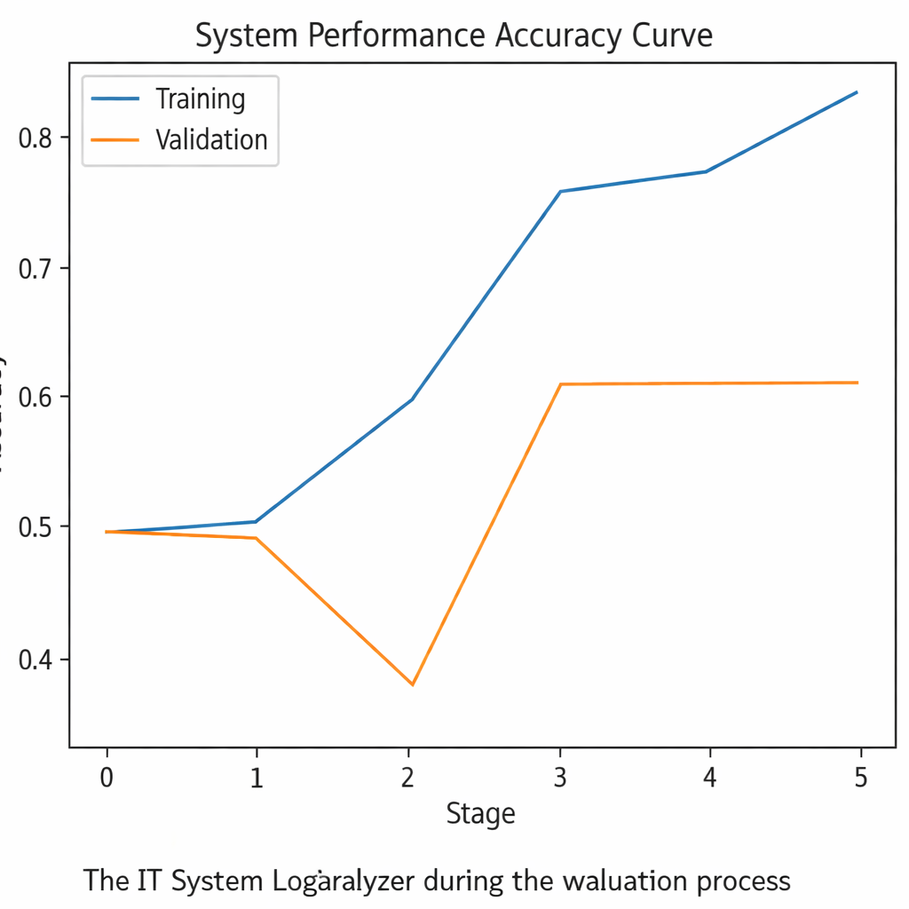

The output of the system was also graphical representation of the system effectiveness. This transformed the processed log entries into ordered table that was easily readable with a clear picture of the timestamp, level of the log entry and the content of the log entry.
In last, the presentation of the results testifies to the fact that the system successfully employs the log file analysis, and proposes useful information that can be used by the administrators to trace the work of the system and define the potential issues.
7.2 Performance Evaluation
The performance of the IT System Log Analyser was tested on the basis of the ability to handle log files properly classifying the log entries and dealing with large volumes of log information effectively. The test was aimed at assessing the accuracy of the machine, speed and applicability.
Log files of various profiles of log entries were also used to test the system so that observations could be made about the behavior of the system in various conditions. The regular expression based parsing mechanism was capable of not just extracting the key fields (timestamp, log level and message) of the log entries but also do it appropriately.
The test of the classification of the logs depending on the severity of logs was also conducted like INFO, WARNING and ERROR. The system could group the arguments of the entries of the logs by level of the log messages in the log lines. This categorization assisted the users to detect very critical problems within the system within a minimal time. Processing speed was the other key performance factor.
The system could read and analyze the log files even in cases when the files carrying the entries of the log were many. The stability in performance was achieved by the system due to an efficient file management and organized data process.
The system was able to read and analyze the log files even when the files containing the log entries were numerous. The system showed stable performance owing to an efficient file management and an organized data process. The usability of the system was also determined using the graphical user interface. Users were able to upload log files very easily, view analyzed data, and filter the data.
The tabular arrangement of log entries enhanced readability and made users to easily interpret the results. Wholesomely, testing of the performance indicates that performance of the system is good in terms of log analysis and the system log information is properly handled.

Metric | Value
Log Parsing Accuracy | High
Log Classification Accuracy | High
Processing Efficiency | Efficient
System Stability | Stable

Table 7.1 Performance Evaluation of IT System Log Analyzer
7.3 Key Findings
A number of significant discoveries were made when implementing and testing the IT System Log Analyzer.
To begin with, the system was able to extract the important extract data contained in the log file by parsing using regular expression.
techniques. The log messages important to the organization of the log entries included timestamps, level of logs and ability to identify the messages in the raw log entries.
Second, the grouping of log messages into the log levels which included the information messages of severity, the warning messages of
Severity, and severity error messages, thus improved the usability of the system greatly. This classification not only allowed the user to easily identify the serious system problems but also allowed one to see error logs without necessarily reading all the log entries.
The filtering feature proved useful; that was the other important discovery. The easiness of users to sort log entries based on the level of severity made it.
Simpler to log analysis and reduced time to identify several events that should take place within a particular system.
The graphical user interface also contributed towards the system usability.
The interface made it easier to interpret and read the system logs as it displays the log in a table format.
The system had a stable performance with large log files as well.
Effective file management and organised data processing enabled the system to be able to process several entries in the logs without affecting the performance..
Overall, the results have indicated that the IT System Log Analyzer is a software that will be useful to examine system logs. This along with the log parsing automation, representation of structured data and storage filtering capabilities provides a reliable system monitoring and troubleshooting alternative.

CHAPTER 8
CONCLUSION AND FUTURE SCOPE
8.1 Conclusion
An automated IT System Log Analyzer system could be developed and adopted by this project where a system log files are read, processed and analyzed as they are created by servers, applications and operating systems. The system was meant to make the daunting task of going through vast quantities of log data simpler, as well as to enable system administrators to quickly identify valuable system events.
The system proposed takes advantage of structured parsing in the logs and regular formulae in order to get the important information in the log files which is made up of timestamps, type of log messages and system messages. The data mined is then presented in the structured format and with the help of a graphical user interface and the system users can easily troubleshoot what their system is doing plus what may be wrong with it.
The system categorizes the log line into a range of severity levels such as INFO, WARNING and ERROR that when administrators see them immediately, they can identify the events that are very crucial and require attention. There is also an option of filtering easy in the system where users can reduce their search to specific types of entries of logs in the logs and this helps in better analyzing the logs.
The results of the implementation are that the system is good in manipulating the log files and generating useful information as well as providing the results in a concise and well structured format.
The developed tool may help save time and effort that they would otherwise use to analyze the logs manually and facilitate monitoring and troubleshooting a system. Overall, IT System _Log Analyzer is a convenient and useful tool of automated log analyzers.
The system explains why software-based applications may assist IT professionals to track system activities, detect errors and enhance the reliability of the system in modern computing infrastructure.
8.2 Future Scope
As good as the proposed IT System Log Analyzer is where system log files can be analysed, during future research a number of potential measures and add-on can be found which can be used to achieve a more efficient and effective distributed system.
One of the aspects of improvement can be regarded as the introduction of machine learning as a method of anomaly detection. The application of machine learning algorithms would help the system to automatically detect the unusual patterns in the log data, as well as detect the potential security threats or system outages.
The other vital enhancement could involve the use of real-time monitoring of logs. Instead of merely examining uploaded log files, the system will be in a position to check real-time log files of responses as emitted by servers and applications and to notify on events that are considered serious immediately.
The system could also be enhanced with advanced data visualization (in the form of graphs, dashboards and statistical summaries). Such visualizations would allow the administrators to visualize the trends of the system performance better and locate trends in log data more easily. Integrating cloud-based architectures to have centralised log management may also be an expansion later on to the system. Cloud integration would also assist an organization in storing and analyzing the logs of other systems on the same platform that would lead to higher access and scalability.
This could be enhanced by the use of user authentication and role-access control and authorized personnel were the only people who could access sensitive log data.
REFERENCES
[1] W. Xu, L. Huang, A. Fox, D. Patterson and M. Jordan, “Detecting large-scale system problems by mining console logs,” in Proceedings of the 22nd ACM Symposium on Operating Systems Principles, Big Sky, USA, 2009, pp. 117–132.
[2] Q. Fu, J. Lou, Y. Wang and J. Li, “Execution anomaly detection in distributed systems through unstructured log analysis,” in Proceedings of the IEEE International Conference on Data Mining, Vancouver, Canada, 2009, pp. 149–158.
[3] M. Du and F. Li, “Spell: Streaming parsing of system event logs,” in Proceedings of the IEEE International Conference on Data Mining, New Orleans, USA, 2016, pp. 859–864.
[4] P. He, J. Zhu, S. He, J. Li and M. R. Lyu, “An evaluation study on log parsing and its use in log mining,” in Proceedings of the IEEE International Conference on Dependable Systems and Networks, Toulouse, France, 2016.
[5] M. Du, F. Li, G. Zheng and V. Srikumar, “DeepLog: Anomaly detection and diagnosis from system logs through deep learning,” in Proceedings of the ACM Conference on Computer and Communications Security, Dallas, USA, 2017.
[6] S. Zhang, Y. Yao and J. Li, “Log-based anomaly detection using deep learning methods,” IEEE Access, vol. 7, pp. 1–10, 2019.
[7] J. Lin, Q. Fu and J. Lou, “Log clustering based problem identification for online service systems,” in Proceedings of the IEEE International Conference on Web Services, 2016.
[8] E. Rozner, T. Benson and A. Akella, “Detecting network anomalies using log analysis techniques,” in Proceedings of the ACM SIGCOMM Workshop, 2014.
[9] B. Behl and A. Behl, “Automated log analysis and anomaly detection in distributed systems,” International Journal of Computer Applications, vol. 178, no. 40, pp. 1–6, 2019.
[10] G. Meng, W. Shang, B. Adams and A. E. Hassan, “An empirical study of log analysis techniques for system reliability,” IEEE Transactions on Software Engineering, vol. 46, no. 6, pp. 1–15, 2020.

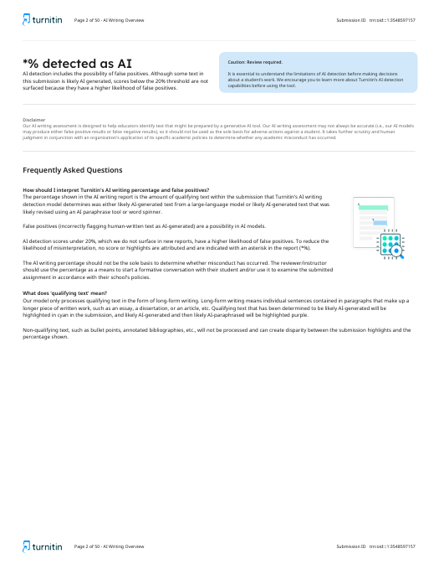
PROJECT REPORT PLAGIARISM REPORT

